📘 DBMS Cheatsheet: Digital Trees

🌳 Digital Trees
- Definition: Trees that branch based on the letters of an alphabet.
- Applications: Information retrieval, XML DBMS.
- Variants:
  - Trie
  - Patricia Tree
  - Prefix Tree
⚠️ Can become unbalanced depending on input.

🔡 Trie
- Idea: Stores strings in a tree; each edge = one character.
- Prefix Sharing: Strings with the same prefix share edges.
- Path Property: Path from root → node = stored word.
- Search Cost: Up to l steps (length of the key).
- Use Case: Dictionary-like structures, auto-complete.

🛠 Patricia Tree
- Problem in Trie:
  - Long chains of unused/rare sub-words.
  - Many sparse nodes → very unbalanced.
- Patricia = “Practical Algorithm To Retrieve Information Coded In Alphanumeric”
- Idea:
  - Skip over unnecessary sub-words.
  - Store number of characters skipped.
  - Keys only confirmed at leaf nodes.
- Advantages:
  - Space efficient.
  - CPU efficient.
  - “Compressed” structure → grows slowly even with large strings.

🌲 Prefix Tree
- Similar to Patricia Tree
- Key difference: Stores skipped sub-words directly in nodes (instead of just counts).
- Benefit: More explicit representation of skipped segments.

📊 Summary Comparison
Structure | Key Property | Space Efficiency | Lookup Steps | Notes
Trie | Each char = edge | Low (many nodes) | Up to key length l | Simple, but can be large
Patricia | Skips unnecessary sub-words (store skip count) | High | Until leaf | Compressed trie
Prefix Tree | Stores skipped sub-words explicitly | Medium | Until node/leaf | Easier to read

✅ Key Insight:
- Trie = straightforward but wasteful.
- Patricia Tree = compressed, efficient.
- Prefix Tree = compressed + explicit skipped segments.

Implementation of DBMS Exercise Sheet 11 Klingemann, WS 2024 / 2025
1a)
Suppose that keys are hashed to three-bit sequences and that blocks can hold two records. Start with a hash table with two empty blocks (corresponding to 0 and 1). Show how the hash table evolves if we insert records with the following hash values:
000,001,…,111 using linear hashing with a capacity threshold of 75%.
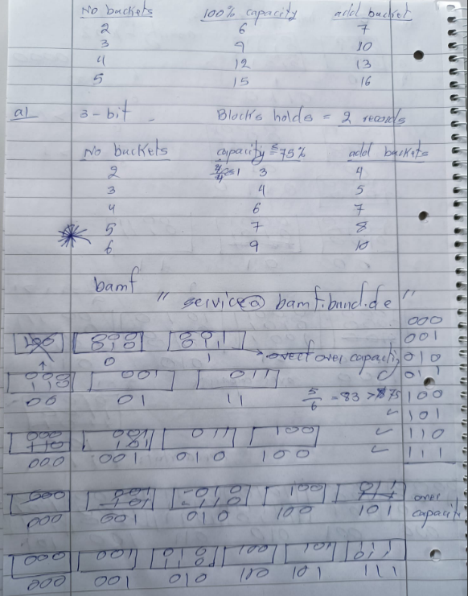

1b)
Suppose that keys are hashed to five-bit sequences and that blocks can hold four records. Start with a hash table with three empty blocks (corresponding to 0, 1, and 2). Show how the hash table evolves if we insert records with the following hash values:
00000,00001,...,11111 using linear hashing with a capacity threshold of 50%.

2a)
Given the set of strings: {apple, apricot, banana, bandana, cat, caterpillar},
construct:
a) a patricia tree b) a prefix tree

2b)
Given the set of strings: {algorithm, align, algebra, alchemy, binary, biology, bioinformatics},
construct:
a) a patricia tree b) a prefix tree
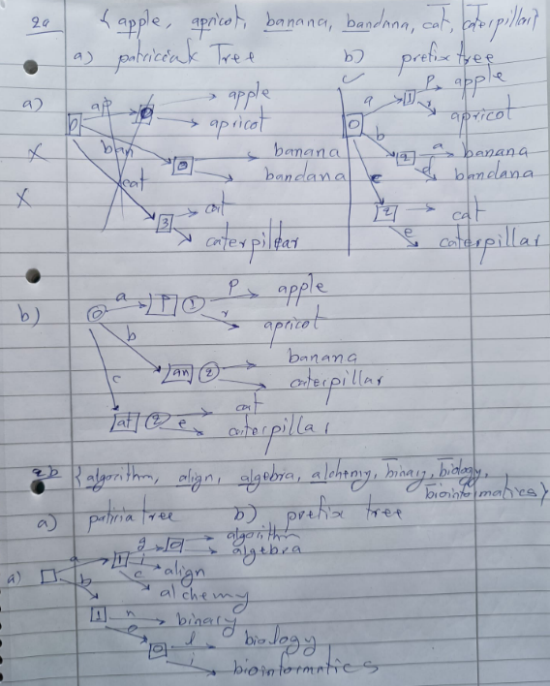
Q.3
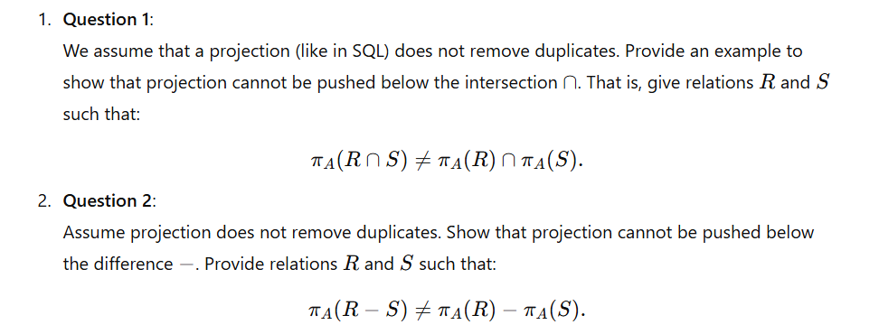

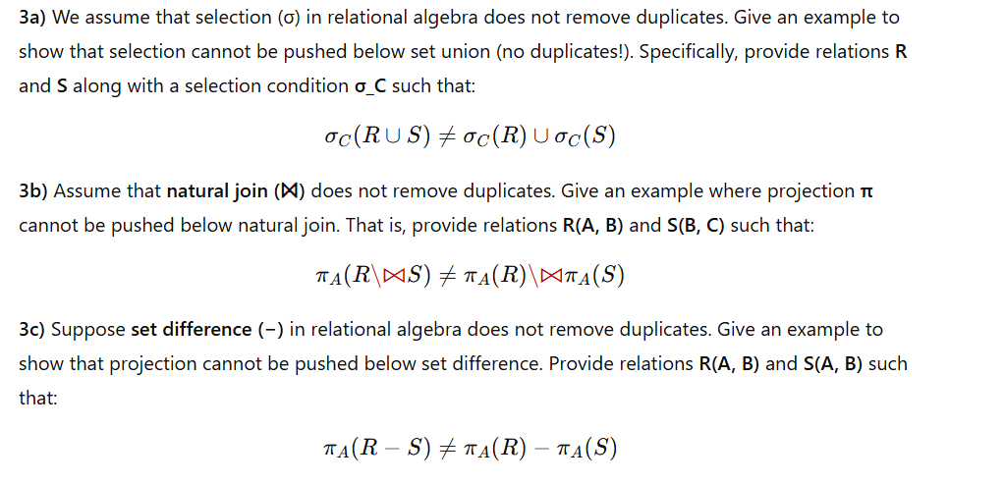

“Digital Trees” (DBMS Implementation, WS 24/25, Prof. Klingemann).

🌳 Digital Trees in DBMS

1. What are Digital Trees?
- Definition: Tree-based data structures where branching is determined by the characters (digits/letters) of keys.
- Used for: Storing and searching strings or sequences.
- Key property: The structure of the tree depends on the sequence of symbols in the key, not on hashing or numeric ordering.
⚠️ Problem: Digital trees can become unbalanced if data is skewed.

2. Variants of Digital Trees
There are three main forms, each solving different issues:
- Trie (classical form, from info retrieval)
- Patricia Tree (compressed form, more efficient)
- Prefix Tree (stores skipped sub-words too)

3. Trie
- Idea: Store strings in a tree, where each edge = one character.
- Shared Prefix: If multiple strings have the same prefix, they share nodes at the top.
- Search Path: To find a word of length l, you follow exactly l steps from root to leaf.
- Nodes: Each node may also link to results (like word frequency, meaning, or database references).
📌 Example: Storing cat, car, dog
(root)
c → a → t (cat)
↘ r (car)
d → o → g (dog)
✅ Advantage: Efficient prefix searches (e.g., auto-complete).
❌ Disadvantage: Can be very large and unbalanced if data is sparse.

4. Problems with Tries
- Long common sub-words → wastes space.
- Unused characters → many empty branches.
- Unbalanced trees → poor performance for some datasets.

5. Patricia Tree (Compressed Trie)
- Patricia = Practical Algorithm To Retrieve Information Coded In Alphanumeric.
- Fixes trie inefficiency by skipping over unnecessary sub-words:
  - Instead of storing every single character, it stores how many characters to skip.
  - Compression means fewer nodes, more compact representation.
- Search: You only know whether a key exists at the leaf (not earlier).
✅ Advantages:
- Space-efficient
- CPU-efficient
- Grows slowly even with large strings
📌 Example: Instead of storing "computation" character by character, Patricia might jump several letters at once if no branching occurs.

6. Prefix Tree
- Similar to Patricia tree.
- Difference: Instead of just storing “number of skipped letters,” it stores the actual skipped sub-word in the node.
✅ Useful for human-readable compression and quick navigation.
❌ Slightly larger than Patricia (since actual substrings are stored).

7. Applications
- Information retrieval (search engines, text indexing).
- Databases: Particularly for XML databases (where element names are strings).
- Auto-complete systems (tries are the foundation of search bar suggestions).
- IP routing tables (Patricia trees are widely used in networking).

📊 Quick Comparison Table
Feature | Trie | Patricia Tree | Prefix Tree
Storage per character | High | Low (compressed) | Medium
Handles long common substrings | Poorly | Efficiently | Efficiently
Stores actual skipped words? | ❌ No | ❌ No | ✅ Yes
Search complexity | O(l) | O(l), but fewer steps | O(l), but fewer steps
Best use case | Auto-complete, string dictionary | Routing tables, XML DBMS | Human-readable storage

Digital Trees slides into a focused practice set with tough, exam-style exercises + worked solutions.

Practice Set — Digital Trees (with Solutions)

1) Build & Analyze a Trie
Task. Insert the words:
{to, tea, ten, in, inn, into, integer, internal} into a trie over lowercase ASCII.
(a) Draw the trie (ASCII sketch is fine).
(b) Count total nodes and edges.
(c) What is the lookup cost for internalize (miss) and ten (hit) in terms of character checks?
Solution (sketch).
- Paths share prefixes: in → into, integer, internal, and te → tea, ten. A compact sketch:
(root)
├─ i ─ n ─ (end 'in')
│ ├─ n (end 'inn')
│ ├─ t ─ o (end 'into')
│ ├─ t ─ e ─ g ─ e ─ r (end 'integer')
│ └─ t ─ e ─ r ─ n ─ a ─ l (end 'internal')
└─ t ─ e ─ (end 'te' no)
├─ a (end 'tea')
└─ n (end 'ten')
- Node/edge counts depend on exact sharing; typical answer ≈ 1 root + sum(unique prefixes).
- Lookup cost is O(ℓ) character steps per the lecture: “up to l steps, where l is the length of the search key.” So:
  - internalize miss → checks 11 chars until mismatch/leaf fail.
  - ten hit → checks 3 chars.

2) Trie Deletion: Lazy vs. Eager
Task. For the trie from Q1, delete words in order: inn, integer, into.
(a) Explain lazy deletion (mark end-of-word).
(b) When can you safely remove nodes (eager compaction)?
(c) After deleting those three, which nodes can be pruned without affecting in or internal?
Solution.
(a) Lazy deletion: unset the terminal flag at a node; do not remove nodes immediately (prevents breaking other words sharing the path).
(b) You may remove a node if it has no children and is not terminal for another word.
(c) After removing inn (terminal off at …in→n), integer, and into, prune tails that became leaf-only chains not used by in/internal. Specifically, the into leaf and the integer branch beyond the split remain removable; shared int/inte nodes survive for internal.

3) From Trie to Patricia (Compressed)
Task. Convert the trie for {go, gone, going, goal} into a Patricia tree: compress single-child chains; store skip length at each edge/node.
(a) Show the Patricia representation with each edge labeled by (substring, skip_len).
(b) How many nodes/edges did you save vs. the raw trie?
Solution.
- Patricia principle: “sub-words that are not needed can be skipped; store the number of letters to be skipped; key existence only known at leaf.”
- Result (one correct variant):
(root)
└─ "go" (skip 2)
├─ "al" (skip 2) → [leaf 'goal']
└─ "n" (skip 1)
├─ "e" (skip 1) → [leaf 'gone']
└─ "ing" (skip 3) → [leaf 'going']
└─ "" (skip 0) → [leaf 'go'] // if you represent 'go' explicitly
- Savings: all single-char steps between shared splits are compressed, typically reducing node count from ~length sum to ~number of branch points + leaves.

4) Patricia Search Trace with Mismatches
Task. Using the Patricia from Q3, simulate searching for gondola.
At each step: show matched edge substring, comparison length, and where the mismatch occurs. Conclude “not found” and state where the failure is detected.
Solution.
- Root → edge "go" matches go.
- Next, branch by next char n: choose edge "n".
- Compare "n" vs key remainder starting n… → matches.
- At node under "n", compare either "e" or "ing" (depending on branching). gondola has next letter d, mismatch occurs before fully consuming any outgoing edge label.
- In Patricia, “We can only determine whether a key exists when we reach a leaf,” but during traversal a branch mismatch → key absent.

5) Prefix Tree vs. Patricia: Stored Data
Task. Explain how a Prefix Tree (as defined in the slides) differs from Patricia in what it stores. Give a small key set where storing the actual skipped substrings helps a downstream application (e.g., pretty-printing paths).
Solution.
- Slides: “Similar to Patricia Tree, but we also store the skipped sub-words in the nodes.”
- Difference:
  - Patricia: stores skip counts (or implicit edge labels).
  - Prefix Tree (here): stores the actual skipped substring explicitly in nodes.
- Example: XML tag paths book/title, book/topic, book/author. Storing actual skipped substrings lets a tool reconstruct full element names directly for navigation/printing in an XML DBMS browser (context from slides: popularity in XML-DBMS).

6) Complexity & Balance
Task.
(a) State lookup complexity for Trie/Patricia in terms of key length ℓ.
(b) Why can digital trees become unbalanced?
(c) Provide a dataset (describe the pattern) that makes a trie pathologically tall.
Solution.
(a) O(ℓ) character inspections in both (Patricia reduces node count but still linear in characters compared).
(b) Keys drive the shape; if many keys share very long prefixes or create sparse branching, the tree height mirrors those prefixes → unbalanced. Slides explicitly note this risk.
(c) Keys like a, aa, aaa, …, a^n cause a tall chain with minimal branching.

7) Edge Cases: Empty String & Prefix Keys
Task. Define precise handling for:
(a) The empty string "".
(b) When one key is a prefix of another (e.g., in vs. internal).
(c) Case sensitivity & non-alphabet symbols.
Solution.
(a) Represent "" by a terminal flag at root.
(b) Mark the shorter key’s node as terminal even if it has children; searches must check terminal flags at each node along the path.
(c) Fix a normalization policy (e.g., lowercase, Unicode NFC); define legal alphabet; reject/escape others to preserve deterministic branching (slides: “branch based on letters of the used alphabet”).

8) Memory Modeling
Task. Suppose a naive trie node stores: array[σ] child pointers (σ=alphabet size, 8 bytes each) + 1 byte terminal flag (pad to 8) → 8σ + 8 bytes per node. With σ=26, estimate space for a trie with 10,000 nodes. Then argue how Patricia reduces space.
Solution.
- Per node: 8*26 + 8 = 216 bytes → ~2.16 MB for 10k nodes.
- Patricia reduces node count by compressing single-child chains; also child sets are typically sparse (use hash/maps/compact vectors), so practical memory is far smaller than dense arrays — matching the lecture’s “space and CPU efficient” claim.

9) Implementation Design
Task. Propose a node layout for each structure:
(a) Trie node
(b) Patricia node
(c) Prefix Tree node (as per slides)
Discuss trade-offs.
Solution.
(a) Trie:
struct Node { bool isEnd; Map<char,Node*> child; }
- Simple; − More nodes.
(b) Patricia:
struct PNode { bool isEnd; vector<(string edgeLabel, PNode* child)> edges; }
Edge label stores substring (or (start,len) into a global key pool); skip can be inferred from label length. + Fewer nodes; − substring storage and split logic.
(c) Prefix Tree (per slides idea): store actual skipped sub-words at nodes (like Patricia with explicit substrings). + Easier reconstruction/printing; − slightly larger storage.

10) Operations Correctness
Task. Give pseudocode for Patricia insert(key) that:
- walks edge labels,
- splits an edge on partial match,
- sets terminal flags correctly when a key is a prefix of an existing key (and vice-versa).
Explain how you ensure the “existence known at leaf” property.
Solution (outline).
- u ← root; i ← 0
- While there’s an outgoing edge e whose label L shares a non-zero prefix with key[i…]:
  - Let k = LCP(L, key[i…]).
  - If k == |L|: consume full label, u ← child(e), i += k, continue.
  - Else (partial match): split:
    - Replace e with new node m labeled by L[0:k].
    - Attach old tail L[k:] under m.
    - Attach new edge with label key[i+k:] to a new leaf with isEnd=true.
    - Done.
- If no matching edge: add new edge labeled key[i:] to a new leaf with isEnd=true.
- If i == |key| at a node: set isEnd=true on that node (handle prefix case).
Why leaf? We finalize keys at terminal nodes after fully consuming characters; traversal outcome is decided only when a full key is matched at a leaf/terminal, consistent with the slide’s note.

